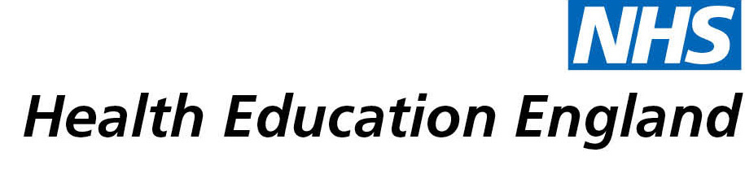

# Library and Knowledge Services case study

# *Birmingham Community Healthcare NHS Foundation Trust – Smallwood Library: Improving the Learning Skills of Foundation Degree Nursing Associates*

Date *28/01/2022*

## Reason for enquiry

## The user wanted help facilitating the improvement of learning skills of Foundation Degree Nursing Associates

## What the knowledge and library specialist did

## The user was signed up to receive regular Knowledgeshare Bulletins.

*“I actually email them out to students and encourage them to select an article to read, and we can discuss it if they want on a one to one, or they can use different articles in their assignments.*

# Impact of input from the library and knowledge service

*“It's* ***made me more efficient, more productive*** *because I can just forward the list onto the admin and say, could you circulate this to all the Foundation Degree students for them to have a look at?”*

## Immediate Impact

*“It's* ***supporting the work that I do*** *with students, with my colleagues and the wider groups of practice assessors that I interact with”*

*“A lot of them (students) are healthcare support workers, health care assistants or assistant practitioners, and they're very used to being given orders from senior nurses or senior professionals and it's very difficult to find your own voice. Then you* ***can use the articles*** *to say, well you said that but what you've just said to me sounds anecdotal unless you can evidence it. Then they say well actually it came out* ***in a knowledge article that you posted****. If I ask who published that, they might say I don't know it was community or journal of whatever it is.* ***Then you realize that you're winning. They're learning to justify their arguments****.”*

*“They're getting an example of first-hand articles that are* ***actually evidence based****. Then it's not just a Google search, and also what I've been trying to do with the knowledge post that I get is to show them that they need to look wider and also start to use the databases to sort of focus their searches so they can get more relevant material rather than going through a lot of irrelevant stuff like they may pick up on Google and it may not be right.”*

*“I think it's a two way traffic.* ***They're learning and I'm learning*** *by their questions”*

*“There's been a lot of reluctance with some students not to have their vaccinations, so I could* ***use the evidence that was produced*** *by the library and incorporate that into what we call action learning discussions. They’re given clinical supervision and allowed to talk about their feelings quite openly and then we can actually direct them to evidence to support, or to say, well, actually the evidence says such and such and that was quite useful because it was quite a difficult conversation that I had with new group because the pressure is there for them to have this vaccination and HEE has actually made it kind of mandatory for them as well.”*

*“It's* ***saving money because it's keeping our fallout rate on the program quite low****. The students that tend to have problems are the ones that are not engaging and you can use knowledgeshare bulletins as a way of encouraging them and where they're not engaged in trying to find out the reasons. It might be a learning issue, use of IT, or it might be that they're just intimidated by reading the articles, then you can work with them.* ***I think it's saved the Trust money by keeping the students well informed, they've got access to really good materials*** *and also if there's problems with them using the materials, it comes to my attention, and you can develop other strategies to entice them to be more involved with it.”*

## Probable future Impact

## Submission by:

Grahame Fraser

Nurse Educator

## For further information on how you can get similar support contact your local NHS library and knowledge service.

**Submission Details**

Name of Organisation *Birmingham Community Healthcare NHS Foundation Trust*

Knowledge and Library Service Contact Email *smallwood.library@nhs.net*

NHS Region Midlands

Title of Case Study *Improving the learning skills of Foundation Degree Nursing Associates*

Sector Community

Group Impacted Nursing and Midwifery

Impact Types [Please select any which apply]

Contributed to personal or professional development.

Contributed to service development or delivery.

Facilitated collaborative working.

Health Information for Patients, Carers and the Public.

Improved the quality of patient care.

Mobilising evidence and organisational knowledge.

More informed decision making.

Productivity and efficiency.

Reduced risk or improved safety.

Saved money or contributed to financial effectiveness.

Improved health and wellbeing of staff and learners

**Consent**

I have consent from individuals referred to in this case study to share details nationally for advocacy and promotion. *[Make bold the option which applies:]*

Yes